**VISVESVARAYA TECHNOLOGICAL UNIVERSITY**

**“Jnana Sangama”, Belgaum -590014, Karnataka.**



**PROJECT WORK-2 REPORT**

**On**

**HOUSEHOLD SERVICES WEB APP**

***Submitted by***

**AADIT TOAMR (1BM23CS001)**

**AARUSH GARG(1BM23CS004)**

**ANAG KAMLESH DEVNANI (1BM23CS031)**

**ARYAN NAVLANI (1BM23CS055)**

***Under the Guidance of***

|  |  |
| --- | --- |
| **Faculty-in-Charge Name**  **Designation** |  |

***in partial fulfillment for the award of the degree of***

**BACHELOR OF ENGINEERING**

***in***

**COMPUTER SCIENCE AND ENGINEERING**



**B.M.S. COLLEGE OF ENGINEERING**

**(Autonomous Institution under VTU)**

**BENGALURU-560019**

**Mar 2024**

**B. M. S. College of Engineering,**

**Bull Temple Road, Bangalore 560019**

(Affiliated To Visvesvaraya Technological University, Belgaum)

**Department of Computer Science and Engineering**



**CERTIFICATE**

This is to certify that the project work entitled **“HOUSEHOLD SERVICES WEB APP”** carried out by **AADIT TOMAR(1BM23CS001), AARUSH GARG(1BM23CS004), ANAG KAMLESH DEVNANI(1BM23CS031), ARYAN NAVLANI(1BM23CS055)** who are bonafide students of **B. M. S. College of Engineering.** It is in partial fulfillment for the award of **Bachelor of Engineering in Computer Science and Engineering** of the Visveswaraiah Technological University, Belgaum during the year 2024. The project report has been approved as it satisfies the academic requirements in respect of **Full Stack Web Development(23CS3AEFWD)** work prescribed for the said degree.

Signature of the Guide                 Signature of the HOD

Dr. Selva kumar S Dr. Jyothy S Nayak

Assistant Professor Prof & Head of Dept of CSE

BMSCE, Bengaluru BMSCE, Bengaluru

External Viva

Name of the Examiner                                                               Signature with date

**B.M.S. College of EngineerinG**

**DEPARTMENT OF COMPUTER SCIENCE AND ENGINEERING**



**DECALARATION**

We, **AADIT TOAMAR(1BM23CS001), AARUSH GARG(1BM23CS004), ANAG KAMLESH DEVNANI(1BM23CS031), ARYAN NAVLANI(1BM23CS055)**  students of 3rd Semester, B.E, Department of Computer Science and Engineering, BMS College of Engineering, Bangalore, hereby declare that, this Full Stack Web Development entitled **HOUSEHOLD SERVICES WEB APP** has been carried out by us under the guidance of Dr. Selva kumar S, Assistant Professor, Department of CSE, BMS College of Engineering, Bangalore during the academic semester Dec 2023 - Mar 2024.

We also declare that to the best of our knowledge and belief, the development reported here is not from part of any other report by any other students.

Signature

**AADIT TOMAR (1BM23CS001)**

**AARUSH GARG (1BM23CS004)**

**ANAG KAMLESH DEVNANI (1BM23CS031)**

**ARYAN NAVLANI (1BM23CS055)**

**TABLE OF CONTENTS**

|  |  |  |
| --- | --- | --- |
| **Serial**  **No.** | **TITLE** | **PAGE NO.** |
| 1 | **Introduction** | 1 |
| 1.1 | Overview | 1 |
| 1.2 | Motivation | 1 |
| 2 | **Software Requirement Specification** | 2 |
| 2.1 | Hardware Requirements | 2 |
| 2.2 | Software Requirements | 2 |
| 3 | **ER diagram of the project** | 3 |
| 4 | **Schema of project** | 4 |
| 5 | **User Interface Design** | 5 |
| 5.1 |  | 5 |
| 5.2 |  | 6 |
| 5.3 |  | 7 |
| 5.4 |  | 9 |
| 5.5 |  | 10 |
| 5.6 |  | 10 |
| 5.7 |  | 18 |
| 5.8 |  | 18 |
| 5.9 |  | 22 |
| 5.10 |  | 22 |

**INTRODUCTION**

* 1. **Overview**

**1.2 Motivation**

**SOFTWARE REQUIREMENTS**

**2.1 Hardware Requirements:**

* A PC with the following or greater specifications:
  + Intel Core i3 or higher
  + 8 GB RAM
  + 500 GB Hard Drive
* A stable internet connection (2Mbps or higher)

**2.2 Software Requirements:**

* Operating system : Windows, Linux
* Front end technologies are : HTML, CSS, JavaScript
* IDE : VS Code,Sublime text
* Back end requirement : PHP/Node.js
* Server : XAMPP server/Node.js

**(This is just a sample for reference only)**

**3. ER DIAGRAM OF THE PROJECT**

EQUIP_NAME

EQUIP_NO

PASSWORDD

**EQUIPMENT_INFO**

EMAIL

SKILL

ADDS

EQUIP_QTY

TRAINER_ID

**TRAINER_INFO**

PASSWORDDDD

ADMIN M N

ADDS

TRAINER_NAME

USERNAME

USERNAME

TEACHESS

ADDS

ATTENDED

PASSWORD

CLASS_ID

M N

M

TRAINER_ID

FIRST

LAST

M

AGE

**CLASSES**

CLASS_NAME

GENDERR

**MEMBER_INFO**

N

DOB

TRAINER_NAME

USERNAMEE

CONTACTT

ATTENDED

EMAIL

M

M

CLASS_NAME

PAYS

USERNAME

SLNO

DAYS

FEE

N

FIRST

MUSER

**ATTENDANCE**

LAST

TUSER

**PAYMENT**

**4. SCHEMA OF THE PROJECT**

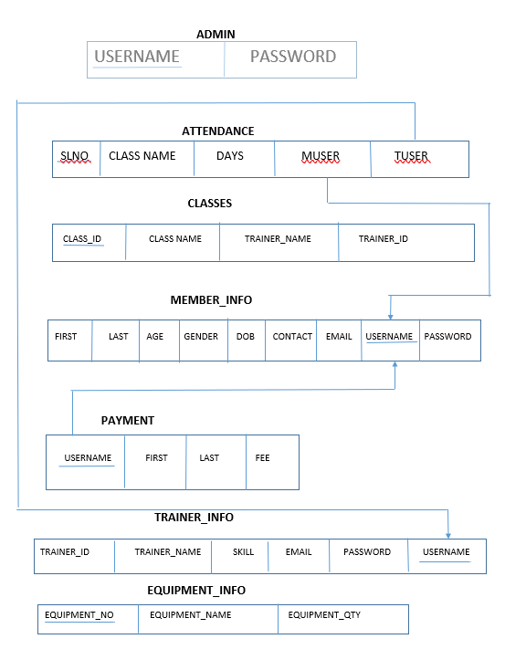

**USER INTERFACE DESIGN**

**Attach various screenshots of each page along with a brief discussion. Please give Figure numbers and names to each of the screenshot attached.**

**REFERENCES:**

**Please provide all the website links you used as reference to build the project**